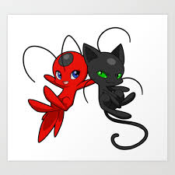

Claws out, Spots on.......

Help Plagg to reach Tikki, his friend, by crossing all the obstacles on the way, created by

Hawk Moth and Mayura.

Miraculous Good Luck....

Bug Out

Instructions to play and Working of the game:

* Open it on any desktop (laptop or computer).
* First, click on 'Run' to start.
* Then, press Space bar to start.
* Use the arrow keys to move Plagg (the black kwami).
* Reach Tikki (the red Kwami) without touching any obstacles or walls.
* The game works in 3 levels, which are ‘the moving plate’, ‘the bouncy balls’ and ‘The jail’.
* Also give a look at your 'Deaths' displayed on the top left corner of the game to check that in how many tries you won.

Link of the game is given below; open it to enjoy the game:

[https://studio.code.org/projects/gamelab/xzJAbaE7AoEdwJOFlWvex8QXlxmBo3FTgyusrMYefN8/](https://studio.code.org/projects/gamelab/xzJAbaE7AoEdwJOFlWvex8QXlxmBo3FTgyusrMYefN8/edit/)